Miranda Lao and Liz Leadley

Machine Gun Jetpack

**Question:** How can you cross the Atlantic Ocean with a machine gun jetpack?

**Model:**

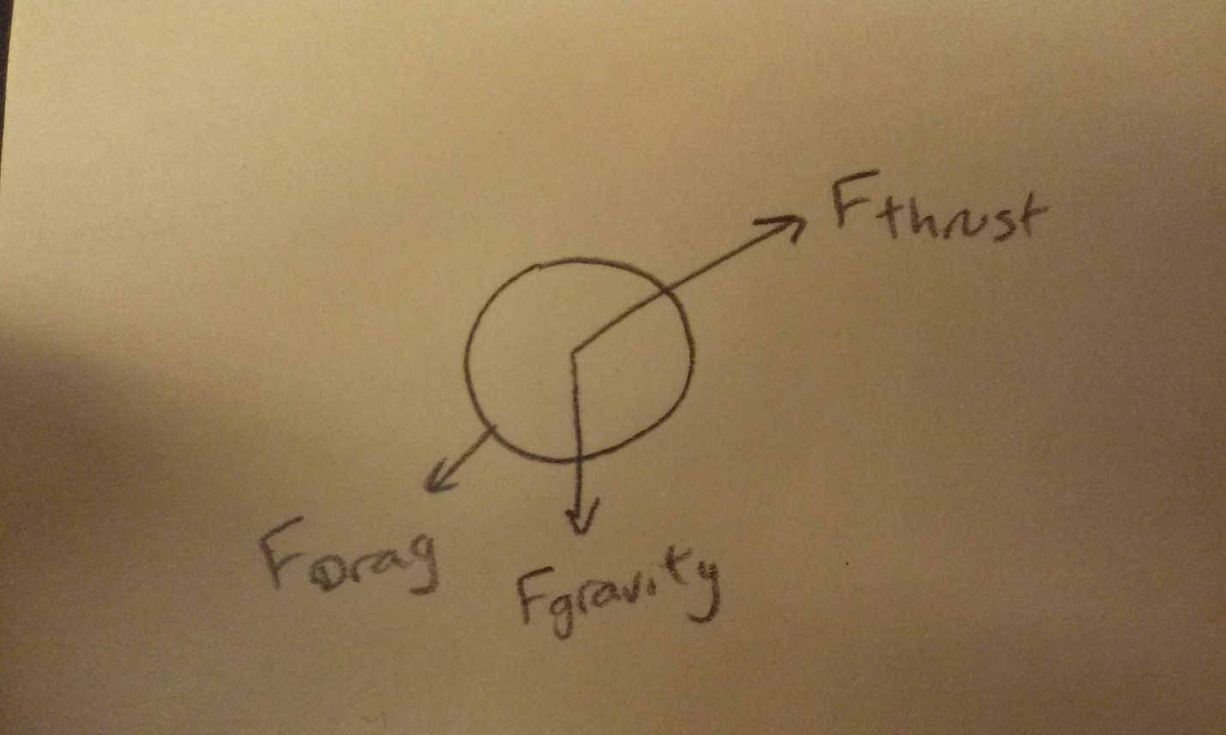

**Equations of motion:**

Fdrag_x = -.5*rho*coeff_drag*area*(v_x^2+v_y^2)*(v_x/sqrt(v_x^2+v_y^2));

Fdrag_y = -.5*rho*coeff_drag*area*(v_x^2+v_y^2)*(v_y/sqrt(v_x^2+v_y^2)); Fgravity = -9.8*mass;

Fthrust_x = firing_rate*(bullet_mass+casing_mass)*-muzzle_velocity*cos(theta_rad);

Fthrust_y = firing_rate*(bullet_mass+casing_mass)*-muzzle_velocity*sin(theta_rad);

dmass = - firing_rate * (bullet_mass + casing_mass);

Thrust is on at 45° until the bullets run out, and then the model runs with thrust set to 0 until the pack hits the ground.

**Graphs:**

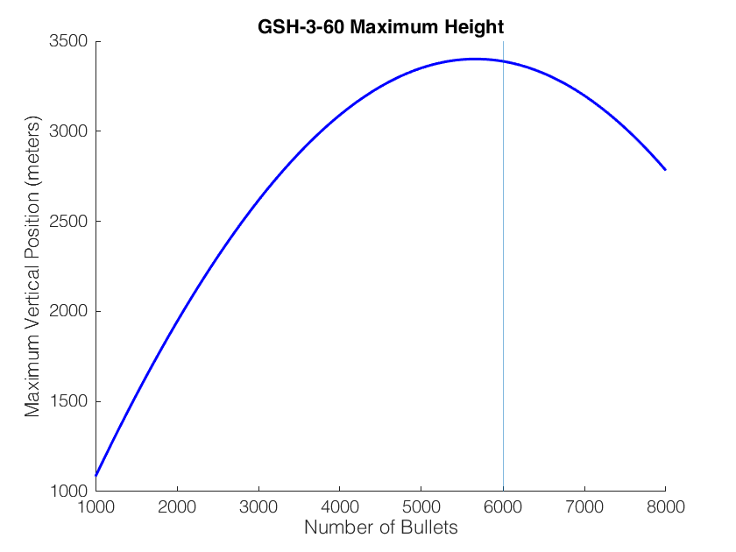

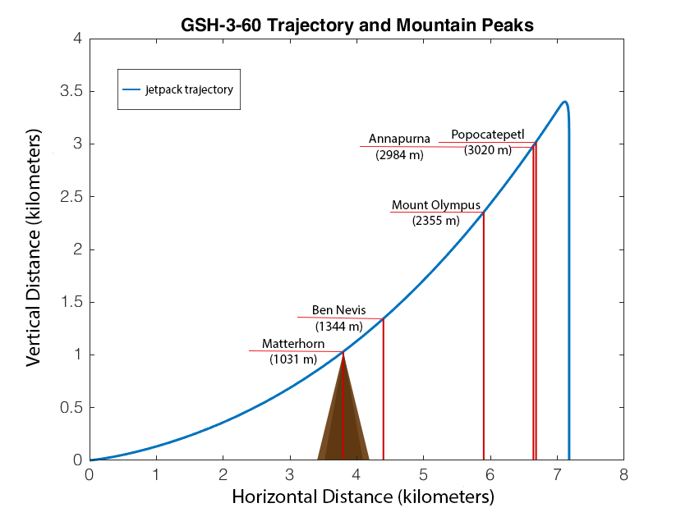

(These graphs will have some validation attached to them)

**Poster Layout:**

